

Nama : muhammad iddar rajab

Kelas : R1

Nim : 210511028

1. Overload 1
2. # Nama   : muhammad iddar rajab
3. # NIM    : 210511028
4. # Kelas  : R1
5. # Matkul : Pemrogaman Berorientasi Objek 2
6. class Vehicle:
7. def __init__(self, distance, time):
8. self.distance = distance
9. self.time = time
10. def calculate_speed(self):
11. pass
12. class Car(Vehicle):
13. def calculate_speed(self):
14. return self.distance / self.time
15. class Bike(Vehicle):
16. def calculate_speed(self):
17. return self.distance / (self.time / 2)
18. class Train(Vehicle):
19. def calculate_speed(self):
20. return (self.distance * 1000) / (self.time * 3600)
21. car = Car(100, 2)
22. bike = Bike(50, 1)
23. train = Train(200, 3)
24. # Output: Kecepatan mobil: 50.0 km/jam
25. print("Kecepatan mobil:", car.calculate_speed(), "km/jam")
26. # Output: Kecepatan sepeda: 100.0 km/jam
27. print("Kecepatan sepeda:", bike.calculate_speed(), "km/jam")
28. # Output: Kecepatan kereta: 18.51851851851852 km/jam
29. print("Kecepatan kereta:", train.calculate_speed(), "km/jam")

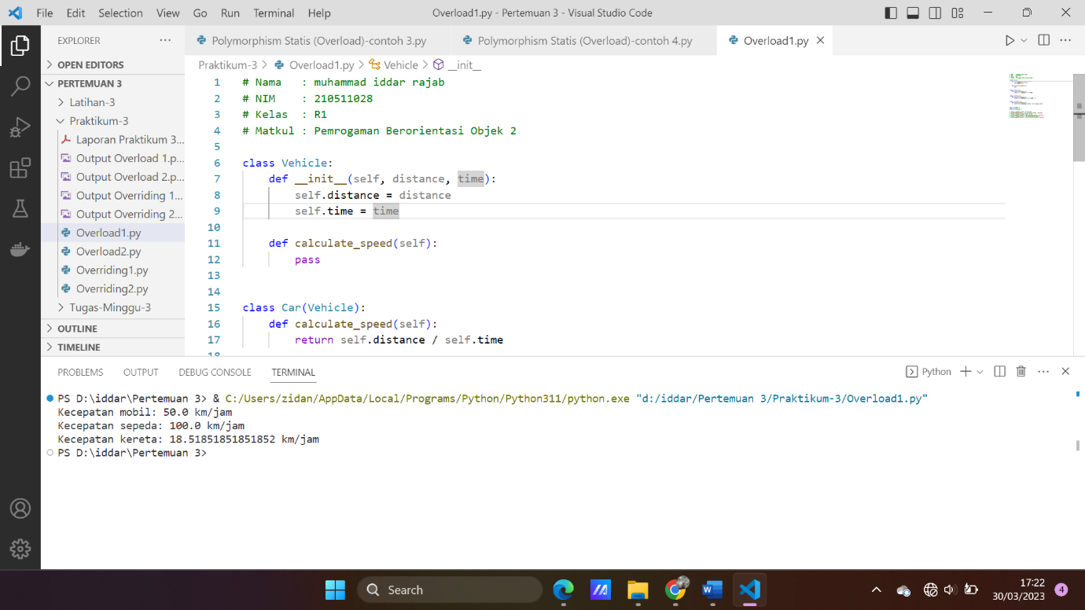

2. overload 2

# Nama   : muhammad iddar rajab

# NIM    : 210511028

# Kelas  : R1

# Matkul : Pemrogaman Berorientasi Objek 2

class Employee:

    def __init__(self, name, salary):

        self.name = name

        self.salary = salary

    def compute_salary(self):

        pass

class HourlyEmployee(Employee):

    def __init__(self, name, salary, hours):

        super().__init__(name, salary)

        self.hours = hours

    def compute_salary(self):

        return self.salary * self.hours

class SalariedEmployee(Employee):

    def compute_salary(self):

        return self.salary / 12

hourly_employee = HourlyEmployee("John Cena", 20, 160)

salaried_employee = SalariedEmployee("Ferdy Sambo", 60000)

# Output: John Cena gaji: 3200

print(hourly_employee.name, "gaji:", hourly_employee.compute_salary())

# Output: Ferdy Sambo gaji: 5000.0

print(salaried_employee.name, "gaji:", salaried_employee.compute_salary())

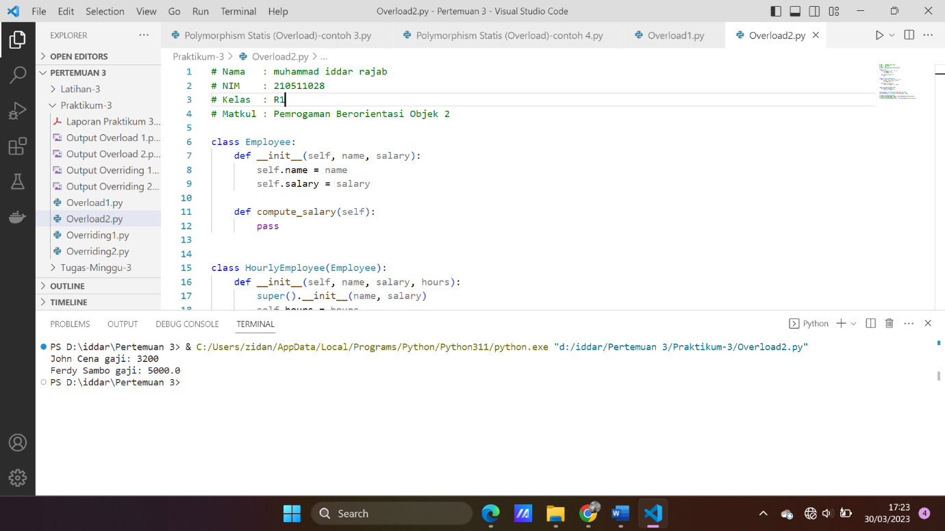

3. overriding 1

# Nama   : muhammad iddar rajab

# NIM    : 210511028

# Kelas  : R1

# Matkul : Pemrogaman Berorientasi Objek 2

def print_sorted(obj):

    sorted_obj = sorted(obj)

    print("Objek yang diurutkan:", sorted_obj)

print_sorted([3, 1, 4, 2, 5])  # output: Objek yang diurutkan: [1, 2, 3, 4, 5]

# output: Objek yang diurutkan: ['apple', 'banana', 'orange']

print_sorted(("orange", "apple", "banana"))

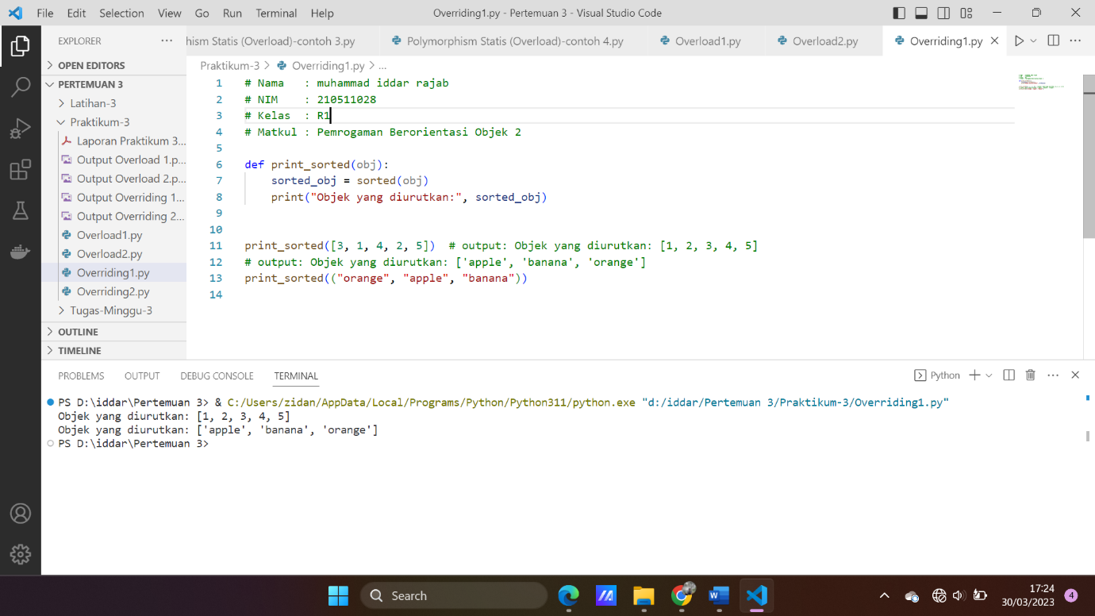

4. overriding2

# Nama   : muhammad iddar rajab

# NIM    : 210511028

# Kelas  : R1

# Matkul : Pemrogaman Berorientasi Objek 2

class Runnable:

    def run(self):

        pass

class Car(Runnable):

    def run(self):

        print("Mobil berjalan.")

class Bike(Runnable):

    def run(self):

        print("Sepeda berjalan.")

class Bus(Runnable):

    def run(self):

        print("Bus berjalan.")

def run_all(objects):

    for obj in objects:

        obj.run()

objects = [Car(), Bike(), Bus()]

run_all(objects)

